Exercise-I
Name:Sanjeev V V S
1NT19IS183

> use dbsanjeev
switched to db dbsanjeev
> db.createCollection("employee1NT19IS183")
{ "ok" : 1 }
>show collections
employee1NT19IS183

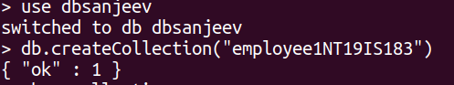
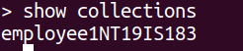

1.The database with 15 documents?

Sol: > db.dbsanjeev.insertMany([
... {fname:"rajesh",Mname:"c",Lname:"r",age:30,salary:30000,designation:"Manager",role:"vat"},
... {fname:"manoj",Mname:"kumar",Lname:"v",age:29,salary:20000,designation:"asst.manager",role:"information head"},
... {fname:"vinayak",Mname:"p",Lname:"bhupal",age:37,salary:50000,designation:"GM",role:"marketing"},
... {fname:"ullaas",Mname:"m",Lname:"l",age:32,salary:40000,designation:"officer",role:"marketing"},
... {fname:"sanjeev",Mname:"p",Lname:"bhupal",age:27,salary:80000,designation:"officer",role:"marketing"},
... {fname:"chota",Mname:"p",Lname:"bheem",age:35,salary:50000,designation:"SE",role:"data analyst"},
... {fname:"seetha",Mname:"rama",Lname:"raju",age:39,salary:60000,designation:"SE",role:"block chain"},
... {fname:"vinayak",Mname:"bahu",Lname:"bali",age:34,salary:50000,designation:"devolper",role:"cloud"},
... {fname:"james",Mname:"p",Lname:"bhupal",age:35,salary:30000,designation:"manager",role:"ml"},
... {fname:"vinayak",Mname:"rahul",Lname:"k",age:37,salary:50000,designation:"GM",role:"marketing"},
... {fname:"alia",Mname:"p",Lname:"bhatt",age:37,salary:90000,designation:"manager",role:"data analyst"},
... {fname:"sanjeev",Mname:"p",Lname:"bhupal",age:37,salary:50000,designation:"GM",role:"marketing"},
... {fname:"sanjeev",Mname:"sai",Lname:"vakada",age:27,salary:90000,designation:"GM",role:"ml"},
... {fname:"vishal",Mname:"p",Lname:"bhupal",age:37,salary:50000,designation:"SE",role:"devolper"},
... {fname:"hanuman",Mname:"neendu",Lname:"diddu",age:32,salary:80000,designation:"AGM",role:"cloud"},
... {fname:"sohan",Mname:"p",Lname:"bhupal",age:37,salary:50000,designation:"GM",role:"marketing"}
... ])

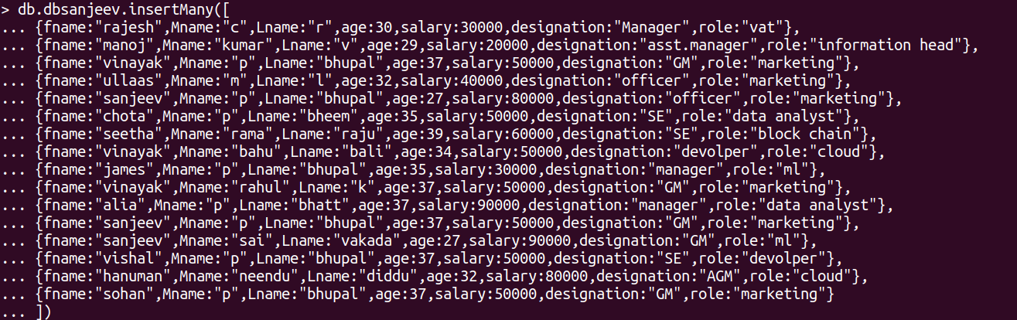
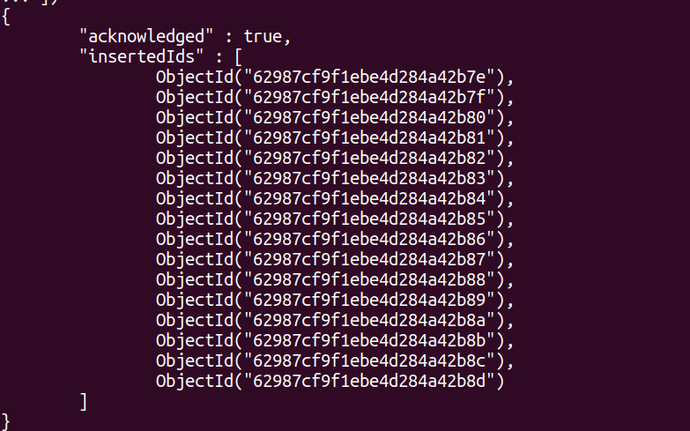

2. List all the records having the salary in range of 20000-35000?

> db.dbsanjeev.find({ $and: [ {salary : {$gte: 20000}}, {salary: {$lte: 35000}} ] }).pretty()
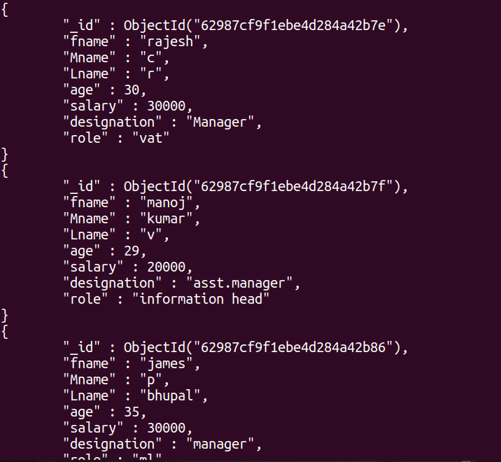

3.list all the employees whose middle name is “kumar”?

Sol:> db.dbsanjeev.find({"Mname": "kumar"}).pretty()
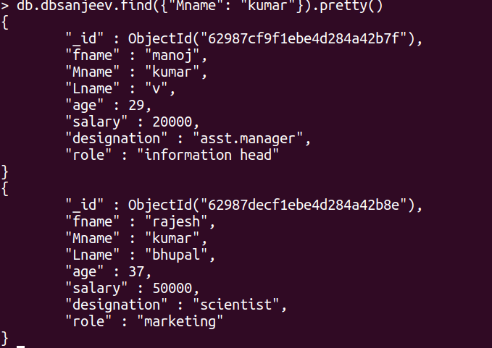

4.list no of employees who has role of manager ?

Sol:db.employee.count({role: "Manager"})
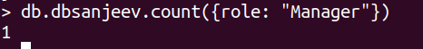

5.find out all documents who age is <35 and salary range of 30000-35000?

Sol: db.employee.find({ $and: [ {age: {$lte: 35}}, {salary: {$gte: 30000}}, {salary: {$lte: 35000}} ] }).pretty()
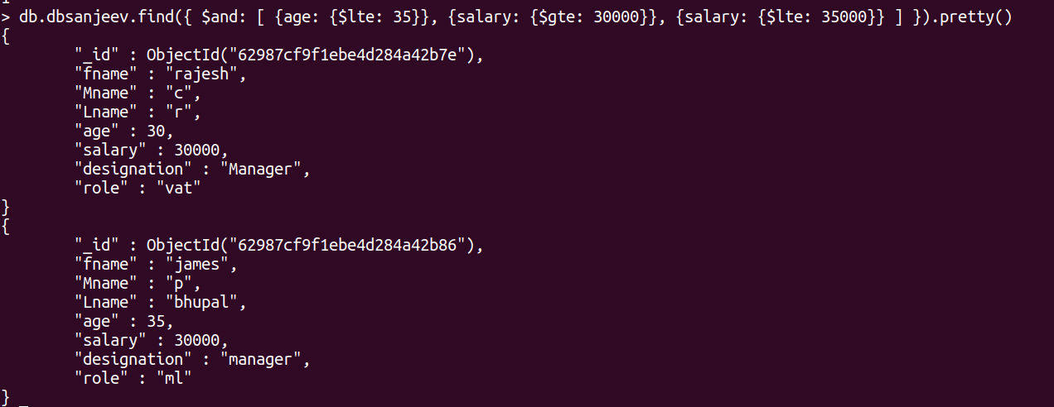

6. Delete an employee whose Fname is “rajesh” and having designation is sceintist?

Sol:db.employee.remove({
... $and:
... [
... {firstName: "Rajesh"},
... {designation: "Scientist"}
... ]
... })
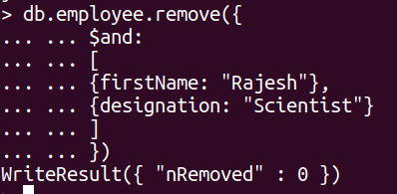

7.update all the employees whose role is team lead with a salary of 55650inr?

Sol:db.employee.updateMany({role: "Team Lead"}, {$set: {salary: 55650}})

8. Group all the Employees by their age(common age should be there) and calculate the average salary obtained in the each group?

Sol: db.employee.aggregate([ {$group: {_id: "$age",AVERAGE: {$avg: "$salary"}}}])
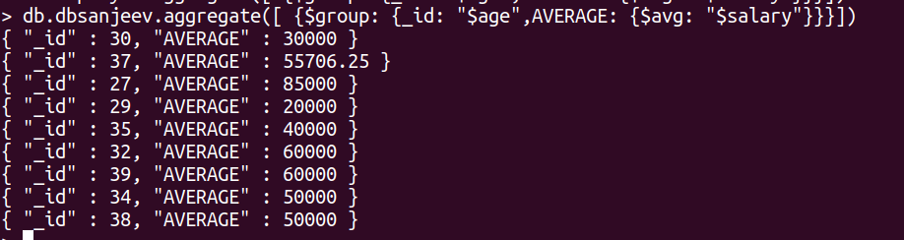

9.Apply the map reduce to perform the above operation and obtain the results ?

Sol:
var mapfunction = function() { emit(this.age, this.salary)}
var reducefunction = function(key, values) {return Array.avg(values)}
db.dbsanjeev.mapReduce(mapfunction, reducefunction, {'out': 'result'})
{ "result" : "result", "ok" : 1 }
